Day 13 (28 June 2025)
112552596 - vsisukhw - Sukhwinder Singh

For tasks questions , refer
https://docs.google.com/document/d/1EcEMFroqTD7U3l83N2dyt8mWLSRgh9YHdZuF194uXFg/edit?tab=t.0

Task 1
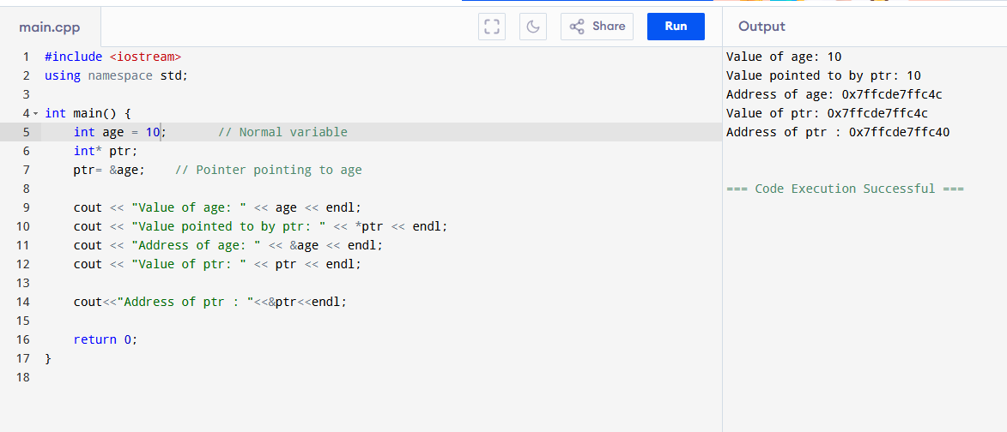

Task 2
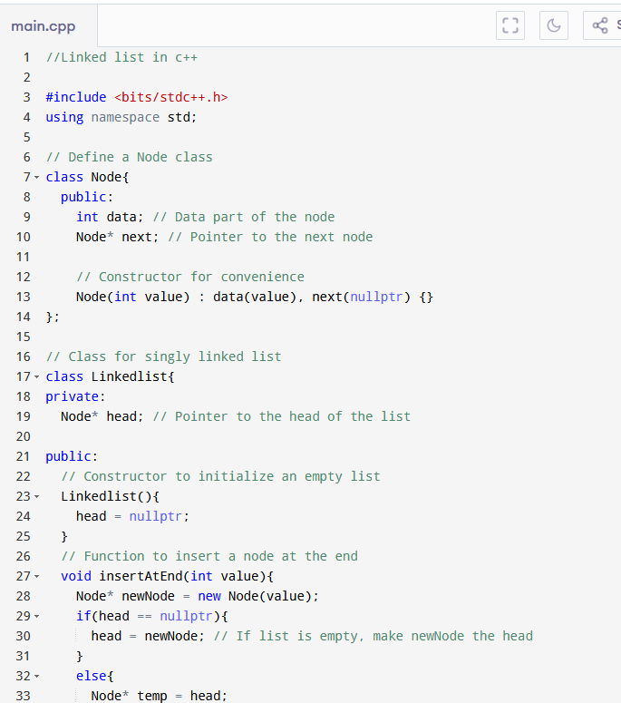
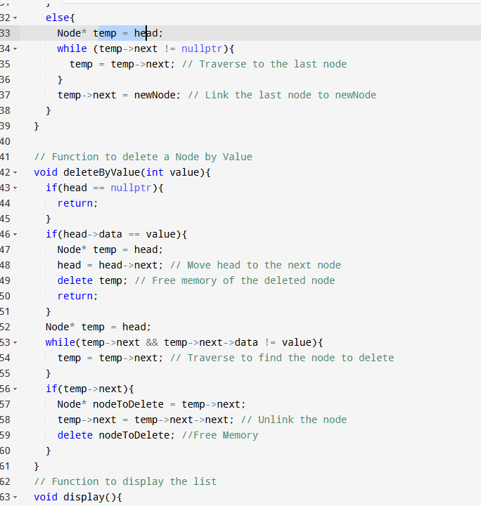
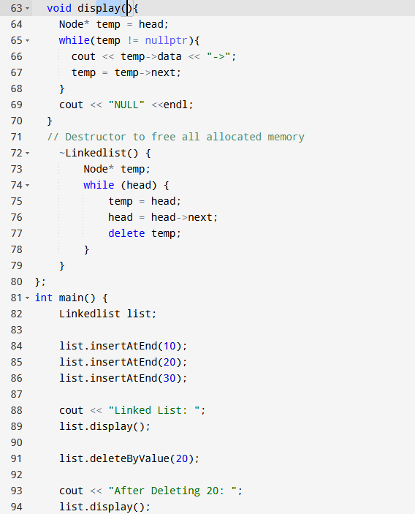
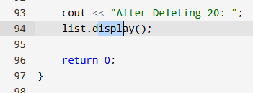
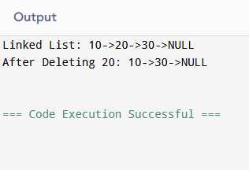

Task 3
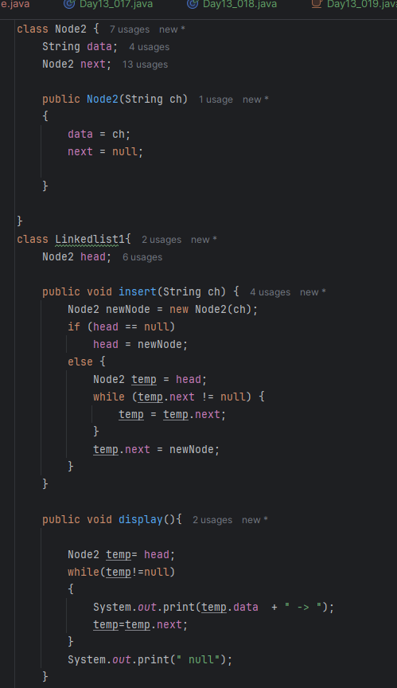
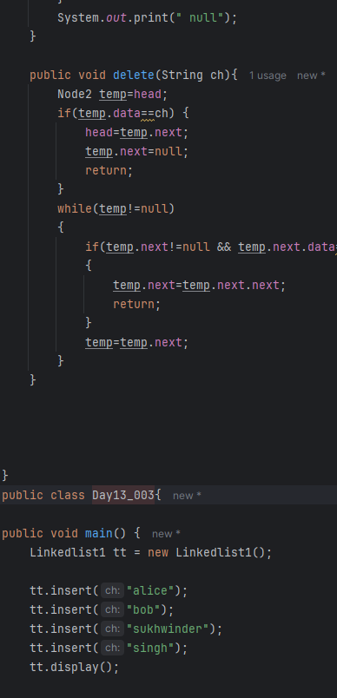
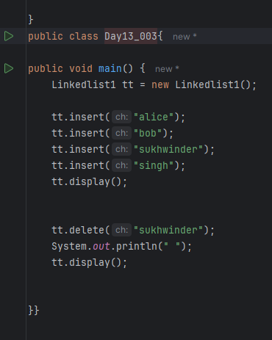
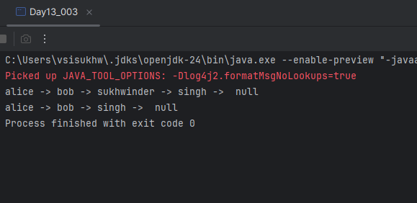

Task 4

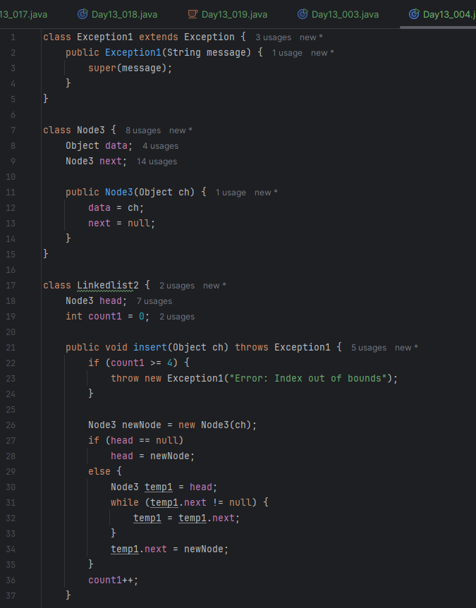
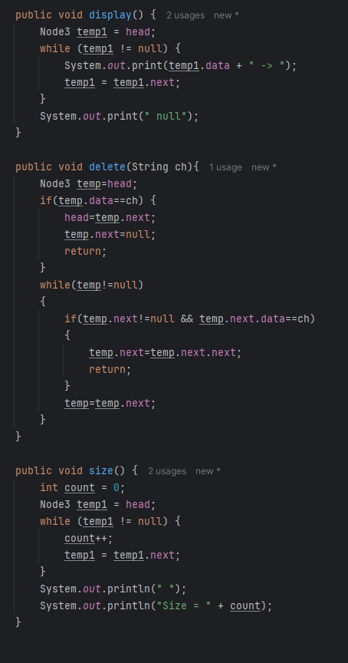
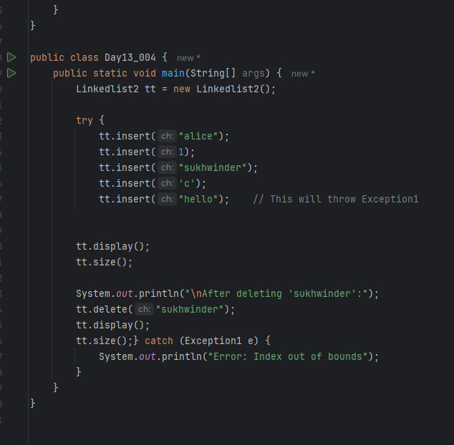
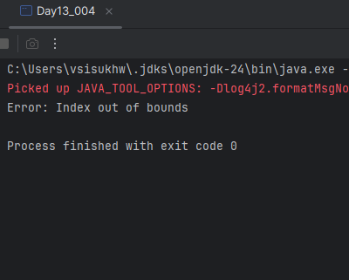

Task 5
Linked List Methods
Method Name | Description
insertAtEnd(data) | Adds a node at the end of the list.
insertAtBeginning(data) | Adds a node at the beginning of the list.
insertAtPosition(index, data) | Inserts a node at a specific position.
delete(data) | Deletes the first occurrence of a node with the given value.
deleteAtPosition(index) | Deletes a node at a specific index.
search(data) | Checks whether a value exists in the list.
contains(data) | Returns true if the value is found; else false.
display() | Prints the list in order.
size() or length() | Returns the total number of nodes.
isEmpty() | Returns true if the list is empty.
clear() | Deletes all nodes in the list.
get(index) | Returns the value at a specific index.
set(index, data) | Updates the value at a specific index.
reverse() | Reverses the entire list.
getHead() | Returns the head (first node) of the list.
getTail() | Returns the last node of the list.

Task 6
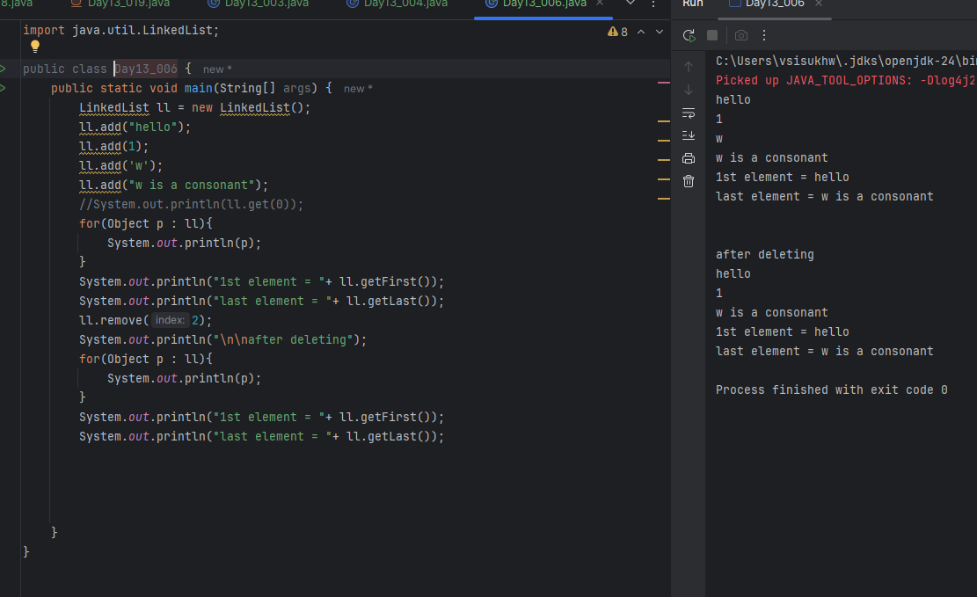
Task 7
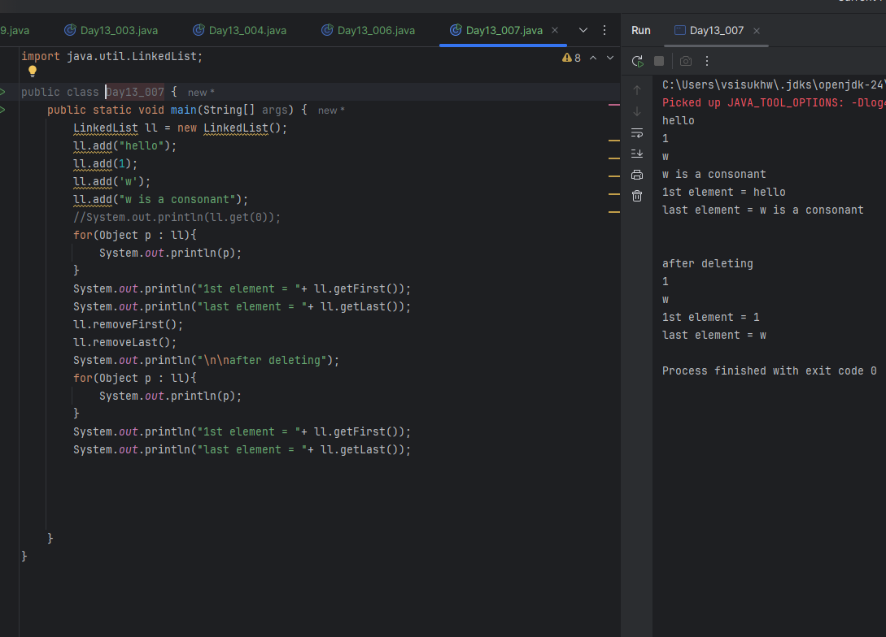

Task 8
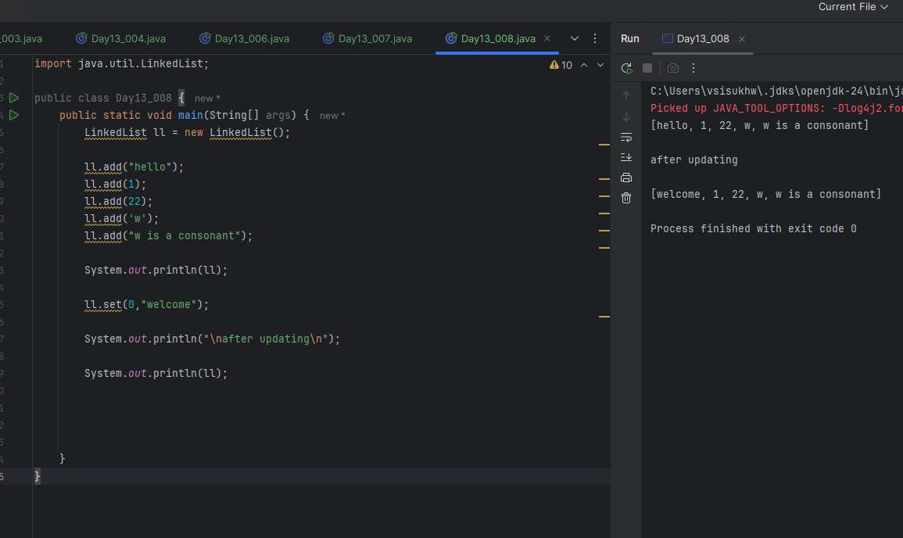
Task 9
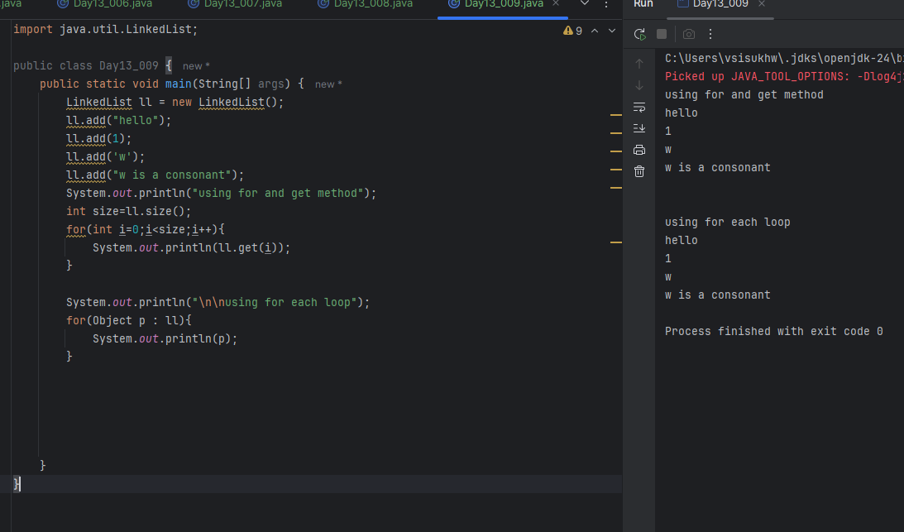
Task 10
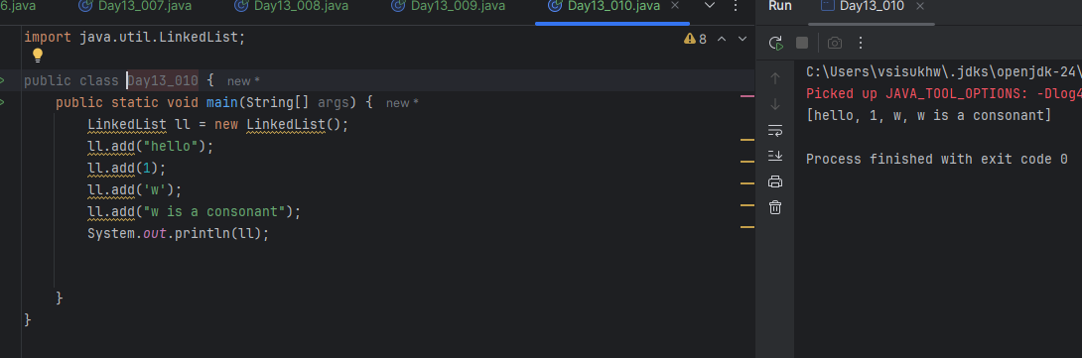
Task 11
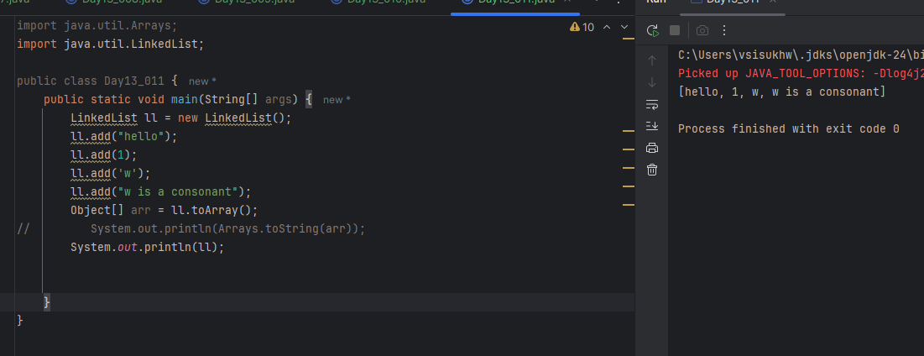
Task 12
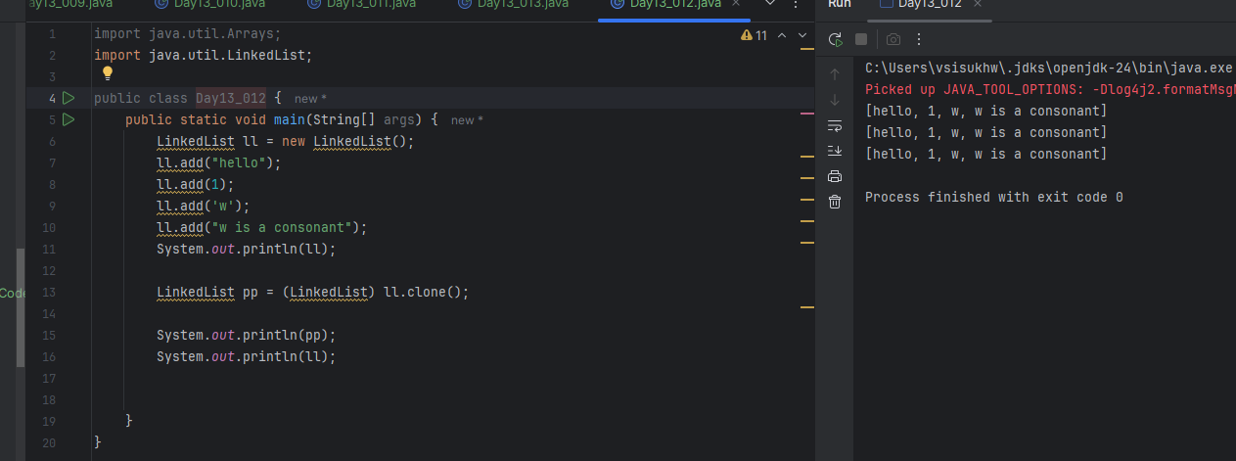
Task 13
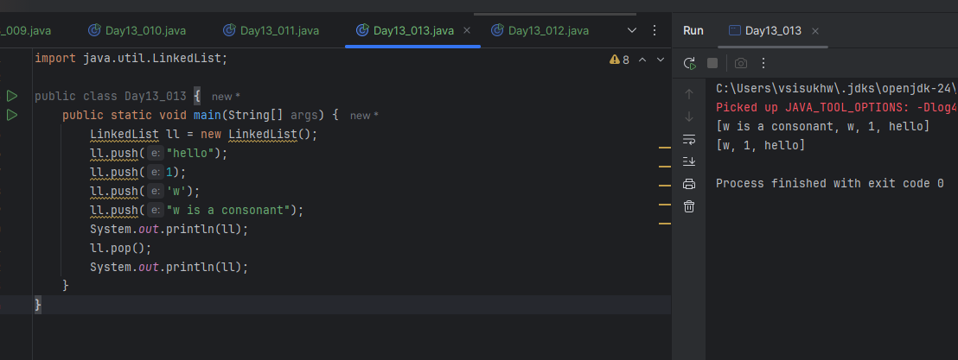
Task 14
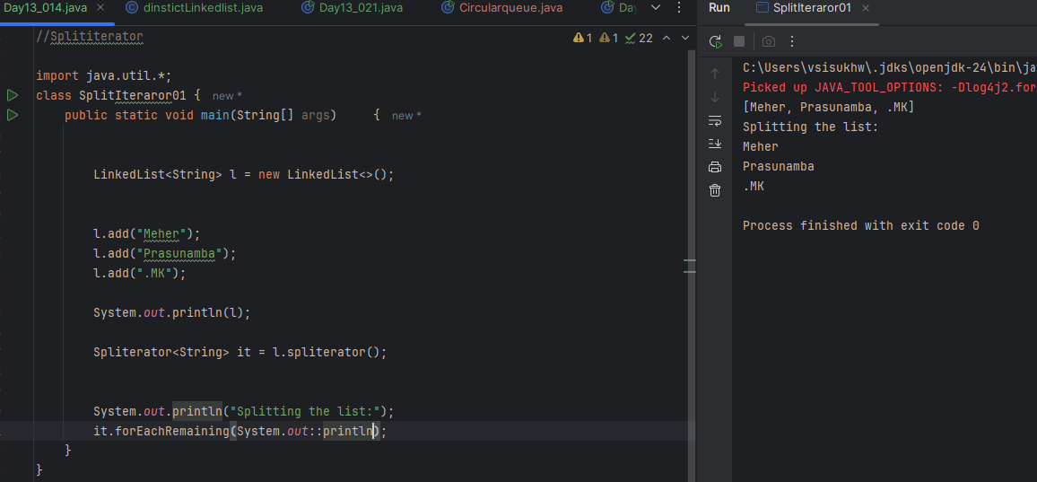
Task 15
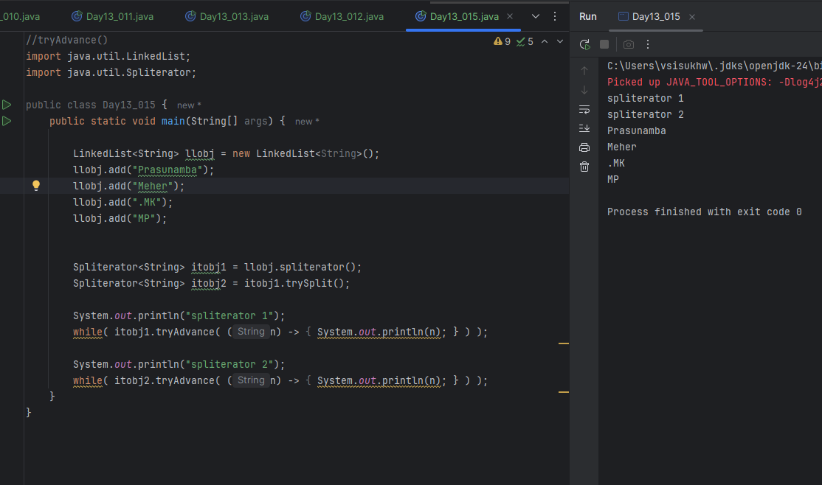
Task 16
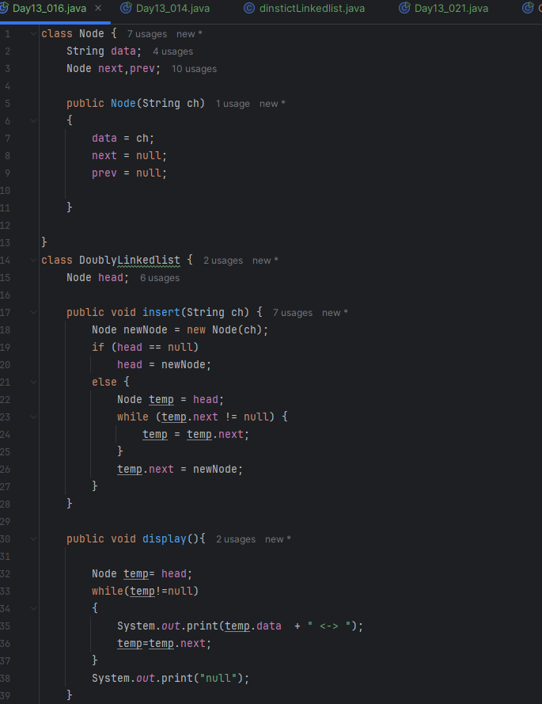
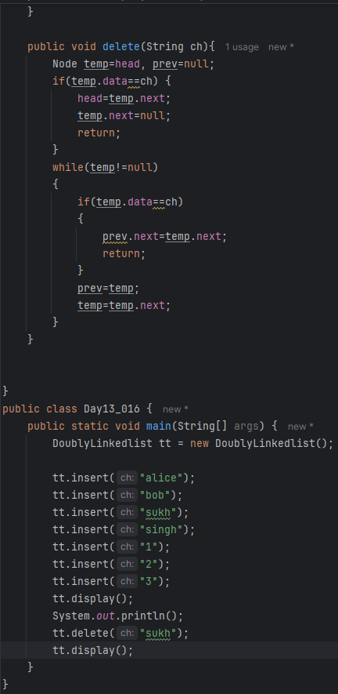
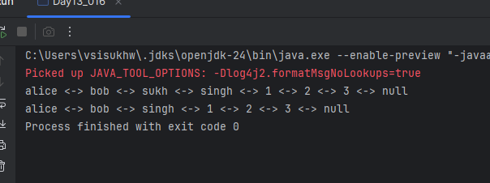
Task 17

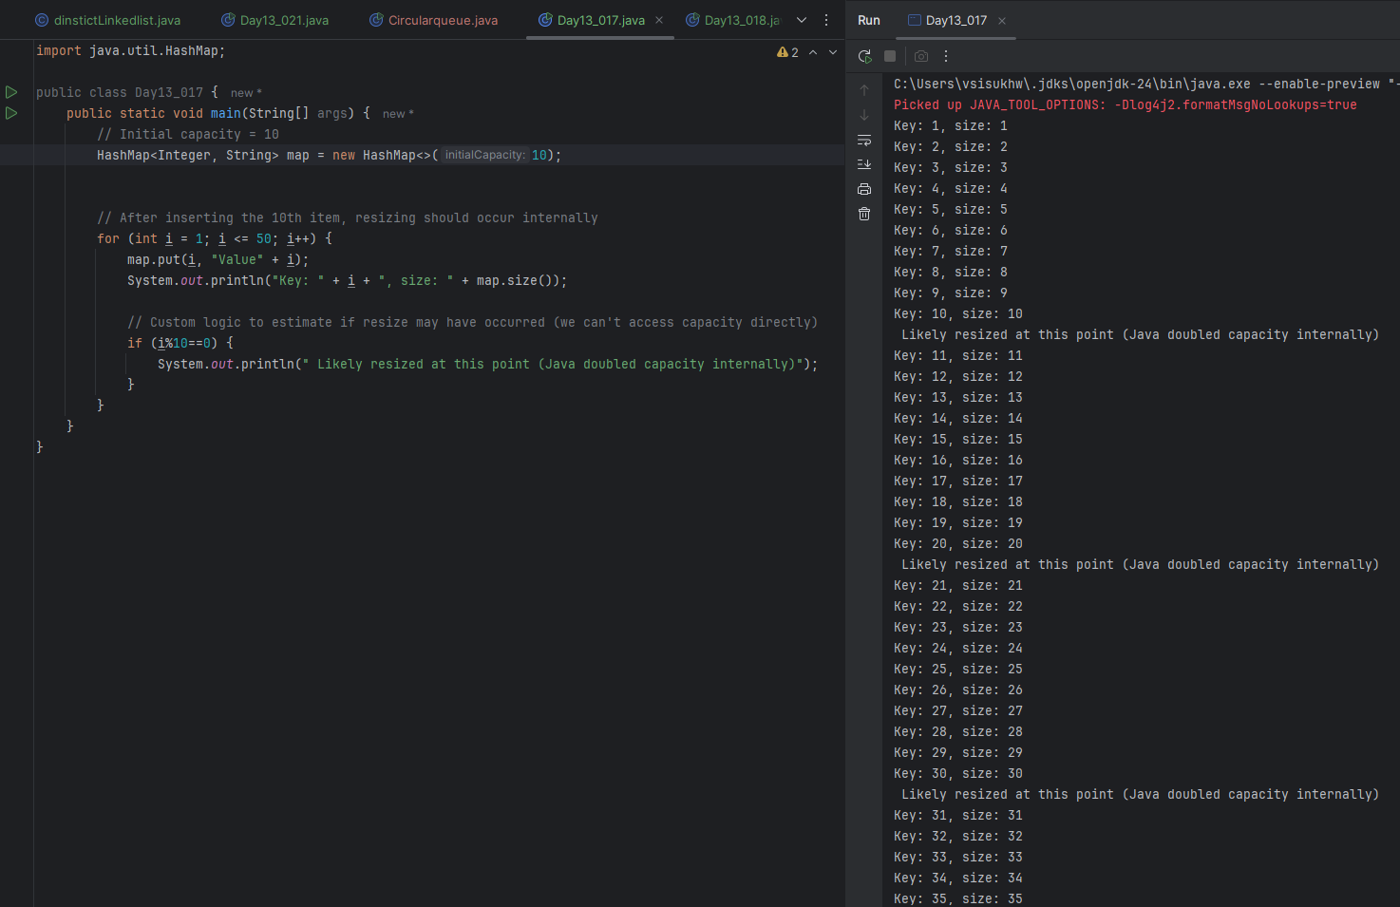
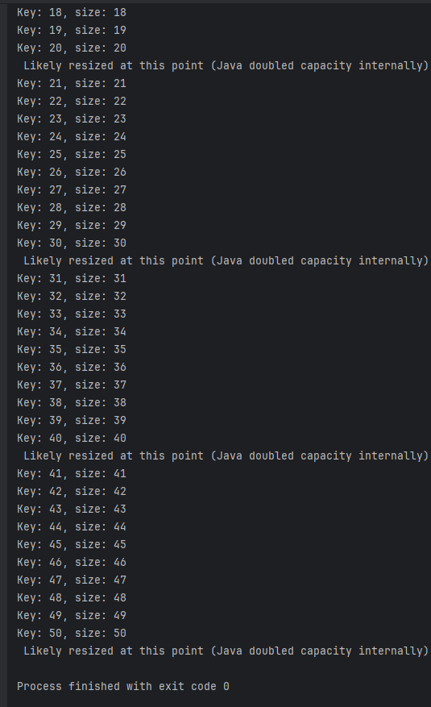
Task 18
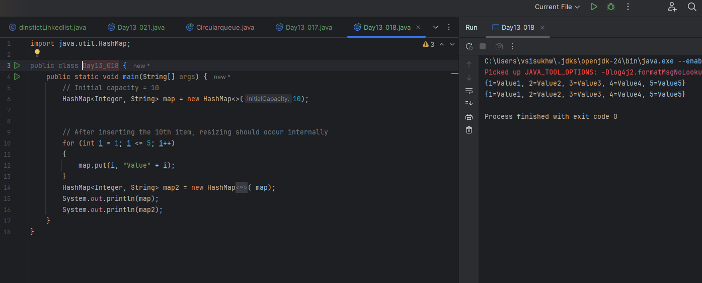
Task 19
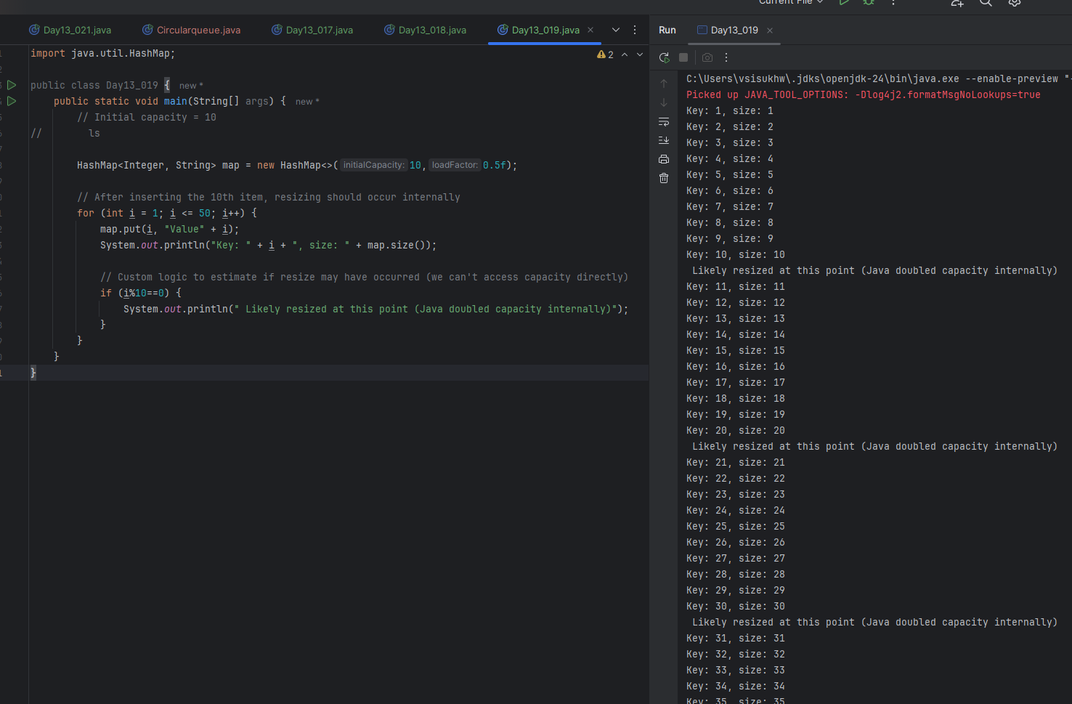
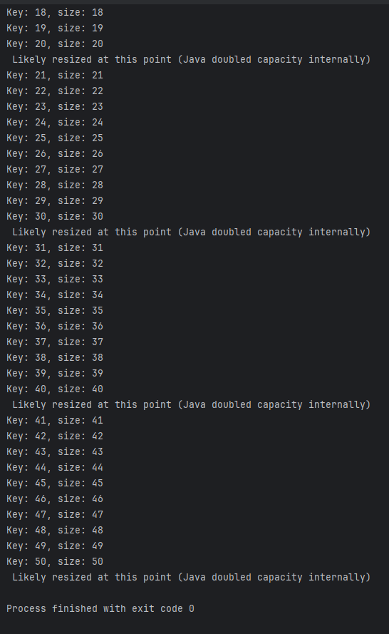
Task 20
Different methods to create a hashmap in java :
1) Constructing a hashmap with default capacity

ex:
HashMap<String, Integer> hm1 = new HashMap<String, Integer>();

2) Constructing a hashmap with a capacity 10

ex:
HashMap<String, Integer> hm2 = new HashMap<String, Integer>(10);

3)copy one map to another map

ex:
HashMap<String, Integer> hm3 = new HashMap<String, Integer>( hm2);

4)
Specifying load factor along with the capacity

ex:
HashMap<String, Integer> hm4= new HashMap<String, Integer>(10, 0.75f);

Initial capacity ===10
Load factor === 0.75f

Task 21
